**Project 1 - Instructions**

**Student ID(CWID):** 884976077

**Full Name:** Andreia Shin

**Clone and download code**

1. Open terminal in computer and type:
2. 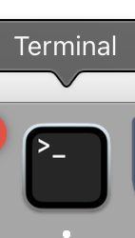
3. In order to run the program we need to make sure your computer have python3 installed. You can check by typing:
   1. python3 -- version
   2. If you see command not found follow the next steps
      1. macOS (with Homebrew):
         1. brew install python
      2. Ubuntu/Debian Linux:
         1. sudo apt update
         2. sudo apt install python3 python3-pip
4. Create a folder in your Documents and name it with something you will remember
5. In the terminal type:
   1. cd Documents
   2. cd "folder name that you created”

It should look like the image bellow

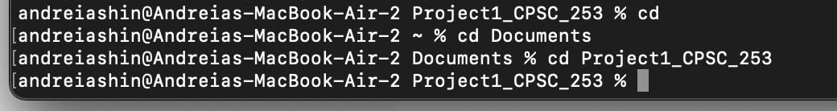

1. Clone the repository and open file - type in terminal:
   1. git clone <https://github.com/deiaashin2/cybersecurity-encryption-decryption.git>
   2. cd cybersecurity-encryption-decryption
   3. If you type “ls” in terminal you should be able to see the files encrypt.py, [README.md](http://readme.md) and test.txt

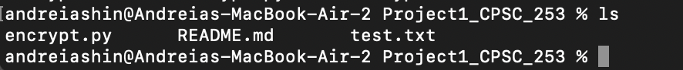

1. Now we will run the program by typing
   1. python3 [encrypt.py](http://encrypt.py)
   2. Select 1 to encrypt message in “test.txt”
   3. Enter the “test.txt” file - you can change the message inside the file if you would like
   4. Select the key - needs to be a number
   5. Press enter
2. You should get something like the image bellow:

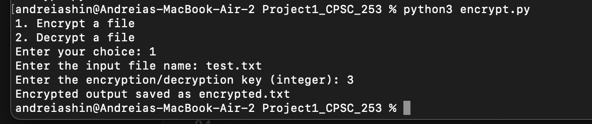

1. Inside your folder you will find a file called ”encrypted.txt” and if you double click it you will see that your message is encrypted with the algorithm from the python file.
2. Now let's decrypt this message! Type this in the terminal:
   1. python3 [encrypt.py](http://encrypt.py)
   2. This time you will select 2
   3. Enter the “encrypted.txt” file
   4. Select the key - needs to be the same number you used on the previous step
   5. Press enter

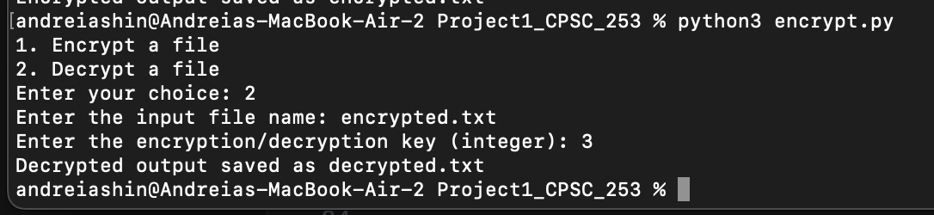

1. Inside your folder you will find a file called ”decrypted.txt” and if you double click it you will see the original message from the “test.txt” file